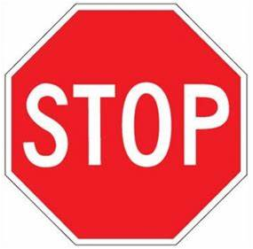
IMPORTANT NOTICE TO ALL VISITORS

Unless you are a health-care professional, or work for a vendor or service provider approved by the LHA, please do not enter this building for your safety and the safety of others.

In order to protect our vulnerable resident community from COVID-19 you should not enter this building unless required to do so by your job or for another immediate resident health necessity.
You are not permitted to enter this building as a visitor if you:
Have any flu symptoms, i. You are not permitted to enter this building as a visitor if you:
- Have any flu symptoms, i.e. fever, cough or shortness of breath
- Have had person-to-person contact with someone who has exhibited coronavirus symptoms in the last 14 days
- Traveled to or from a high risk area in the last 14 days

- . fever, cough or shortness of breath
- Have had person-to-person contact with someone who has exhibited coronavirus symptoms in the last 14 days
- Traveled to or from a high risk area in the last 14 days

If you must enter this building, please sign the visitor log. If you have any questions please contact ____________ at ____________.

