Congratulations on Becoming
a Social Security Representative Payee!
The Social Security Administration recognizes your work on behalf of those who need help and we are committed to providing you with the guidance and assistance you need to fulfill your duties as representative payee.

Welcome to the Guide
The Social Security Administration (SSA) has developed this Guide for Organizational Payees to help organizations serving as representative payees. It should help you understand the duties and responsibilities of a payee.
We encourage you to use the Guide to develop your payee system and procedures to meet the needs of your beneficiaries and maximize your organization’s resources.
You and your staff, especially those who work with beneficiaries, manage their funds, and report changes to SSA should read and have access to the Guide.
For your convenience, the Guide, as well as other payee information, is available online at:
http://www.socialsecurity.gov/payee.
If you cannot find the information you need in the Guide, or on our website, you may visit your local Social Security office or call our toll-free number at 800-772-1213.

If you call, you can speak to a service representative between the hours of 7:00 a.m. and 7:00 p.m. on business days.
If you call about a specific case, be sure to have the following information available:
- The beneficiary’s name, Social Security Number (SSN), date and place of birth, mailing address and one other unique identifier such as benefit amount; and
- The name, address and employer identification number (EIN) of your organization.

New in the Guide
We have rewritten and reformatted the Guide to make it easier to access important information.
A sample monthly accounting ledger appears in the Exhibits section of the Guide. You may use the sample ledger, or something like it, to help you keep track of the funds you manage. This will make reporting to us much easier.

Table of Contents
Terms Used in this Guide 5
Overview 9

Who Needs a Payee? 11

Beneficiaries with a Drug Addiction or

Alcohol Condition 12
The Role of a Representative Payee 13
About Payee Fees 14
How to Become a Representative Payee 15
Duties of a Representative Payee 16
Other Ways a Payee Can Help 18
Reporting Events to SSA 19
Additional Reporting Events for
SSI Beneficiaries 21
Limits to What a Payee May Do 22
Proper Use of Benefits 23

Handling Large Sums of Money 24

Special Rules for Beneficiaries

Living in Institutions 25

Using Funds for Legal Dependents 27

Important Information About the

Use of Benefits 27
Payee Misuse of Benefits 30
Managing and Conserving Funds 32
About Account Titling 33
Collective Accounts 33
Conserved Funds
After You Stop Being Payee 36
Conserved Funds
After the Beneficiary Dies 36

Payments Received After

Death of the Beneficiary 37

Dedicated Accounts – Minor Disabled Children

Receiving SSI 39

Using Dedicated Account Funds 40

Misapplication of Dedicated Account Funds 42

Reporting on Monthly Benefits and

Dedicated Account Funds 43

Overpayments 44
Payee Monitoring and Accounting 46
Developing an Accounting System 48

Subcontracts for Accounting Functions 49

Managing Beneficiary Funds – Security 50
Fee for Service (FFS) Payees 54

Getting Approved as a FFS payee 55
Fee Amounts 58
Restrictions on FFS Payees 58
Being Payee – Best Practices 61
Protecting Beneficiaries from Identity Theft 64
More Information on Identity Theft 66
Medicare and Medicaid 68
Frequently Asked Questions 69
Other Available Publications 74
Exhibits 77
1 –Sample SSA-6234-F6 Representative Payee Report
2 - Sample SSA-6233-BK Representative Payee Report
of Benefits and Dedicated Account
3 - Sample Contract for Payee and Beneficiary
4 - Monthly Beneficiary Accounting Ledger

Terms Used in this Guide
Beneficiary – an individual receiving Social Security or Supplemental Security Income (SSI) benefits
Collective Account – a single savings or checking account in which a representative payee holds funds for multiple beneficiaries for whom they serve. Collective accounts must be approved by SSA before beneficiary funds can be deposited into them. The account must clearly show the individual amounts for deposits, withdrawals and interest earned for each beneficiary.
Conserved Funds – funds saved, or conserved, by the representative payee. Funds in excess of the amount needed to meet a beneficiary's current or reasonably foreseeable needs are the property of the beneficiary. A payee must conserve these funds on behalf of the beneficiary.
Custody – the control, supervision and care of the beneficiary. A payee may have physical custody of the beneficiary, meaning that the beneficiary actually lives with an individual payee or is in the care of an organizational payee. A payee may also have legal custody meaning that a court has issued an order placing a beneficiary in the care of an individual, institution, or other agency.
SSA does not consider temporary changes, such as vacations or short trips by the beneficiary, as a change in custody.
Dedicated Account -- a specific, separate account at a financial institution that is used only for the deposit of large past-due SSI payments (usually a payment covering more than 6 months of the current benefit rate) made to a representative payee on behalf of a disabled child under age 18.

Drug Addiction or Alcohol Condition (DAA) -- an SSA determination that a disabled beneficiary has a drug addiction or alcoholism disorder. SSA does not pay disability benefits based primarily on a DAA condition but we may determine an otherwise disabled beneficiary has a DAA condition.
Fiduciary – a person or entity authorized to handle money on behalf of another.
Fiduciary Account -- an account established by a person or entity on behalf of another party.
Incapable – a determination made by SSA that a beneficiary is unable to manage or direct the management of funds. SSA pays benefits due a beneficiary determined incapable through a representative payee. SSA bases a determination of incapability on various kinds of evidence.
SSA’s determination of incapability is not the same as a State court’s finding of “legal incompetence” and the two findings are not necessarily equivalent.
Incompetent (or legally incompetent) – a decision made by a State court that an individual is unable to manage his or her affairs. SSA presumes a beneficiary found legally incompetent by a court to be incapable and requires the appointment of a payee for SSA benefits. On the other hand, however, a beneficiary SSA determines incapable may not be found legally incompetent by a court.
Before we select a payee based on a State court’s finding of legal incompetence, we must receive a copy of the court ruling as part of the documentation to support our decision.
Legal Guardian/Conservator – someone appointed by a court of law to be responsible for a minor or an incompetent adult. In some States, the terms “guardian” or “conservator” have the same meaning regarding persons placed in charge of another’s affairs.
SSA does not automatically select a legal guardian or conservator as payee for a beneficiary. Instead, SSA will make an independent judgment in every case to determine who will best serve the beneficiary as payee. This may or may not be a legal guardian/conservator.
Misuse – Using the funds a payee manages on behalf of a beneficiary for someone other than the beneficiary. Misuse is prosecutable theft and payees who commit misuse must make restitution. The misuse of benefits is considered an overpayment.
Overpayment – an amount of benefits paid to a beneficiary, or to the payee of a beneficiary, to which the beneficiary is not entitled; or funds misused by a payee.
Funds misused by a payee are an overpayment to the misusing payee and the payee is liable for repayment of the debt.
Power of Attorney – a legal authorization granting someone the right to transact certain business for an individual. It does not diminish the rights of the individual and does not necessarily involve capability or competence.
The U.S. Treasury Department does not recognize power of attorney for the purpose of negotiating Federal payments, including Social Security or SSI payments. Therefore, a person with power of attorney for an incapable or incompetent beneficiary must still file apply to SSA to become payee and to receive benefits on behalf of the beneficiary.
Representative Payee – an individual or organization appointed by SSA to receive and manage the social security or SSI benefits of another person.
A representative payee must use the funds they manage for the exclusive use and benefit, and in the best interest of, the beneficiary.

We categorize payees into two broad groups:
Individual payees – These include relatives, guardians, friends, or any other interested person who is in a position to care for the beneficiary.
Organizational payees – These can include social service agencies, institutions, State or local government agencies, or financial institutions.
RSDI Benefits – Retirement, Survivors and Disability Insurance benefits paid by SSA under Title II of the Social Security Act. These are also sometimes called social security benefits. They are based on the earnings of a worker who has paid into the system by paying Federal Insurance Contributions Act (FICA) tax for a specified period of time. A worker, or his or her family, can receive RSDI benefits upon the worker’s attainment of a certain retirement age, disability, or death.
SSI Benefits – Supplemental Security Income benefits paid by SSA under Title XVI of the Social Security Act for aged, blind, and disabled persons with little or no income or resources.

Overview
The Social Security Administration (SSA) is an independent Federal government agency that administers two major benefit programs. For many Americans, these programs are an important source of income. In fact, for some they may be the only source of income.
The largest of these programs is the Retirement, Survivors and Disability Insurance (RSDI) program. This program is often referred to as Social Security.
The other is the Supplemental Security Income (SSI) program.
Social Security is a social insurance program that protects workers and their families from a loss of earnings because of retirement, death, or disability. Social Security benefits are based on the earnings of a worker who has paid into the system by paying Federal Insurance Contributions Act (FICA) tax for a specified period of time. A worker, or his or her family, can receive RSDI benefits upon the worker’s attainment of a certain retirement age, disability, or death.
The amount a beneficiary receives depends on the age at which the worker retires, becomes disabled, or dies and how long he or she worked.

SSI is a Federal income maintenance program for aged, blind, and disabled persons with little or no income or resources. Funding for SSI does not come from Social Security contributions. Rather, the United States Treasury’s general funds provide financing for this program. Some States supplement the maximum SSI Federal payment.
Because SSI is a needs-based program, the amount of resources or income an individual has may affect their eligibility to payments.
To receive SSI payments, a person must be age 65 or older, blind or disabled and must have limited income and resources. In order to qualify, an individual cannot have over $2,000 in countable resources ($3,000 for a couple).
(Important: In determining resources, SSA usually does not count the value of the beneficiary’s home and one car.)
Some individuals may receive both Social Security and SSI benefits. Eligibility depends on the individual meeting the requirements for each program.
As a payee, you need to know what type of benefit(s) a beneficiary is receiving and what events or changes you need to report to SSA. (See pages 19-21 for a payee’s reporting responsibilities.)

Who Needs a Payee?
We always pay benefits through a payee for an adult judged legally incompetent by a State court.
We usually pay benefits through a payee for a minor child.
Otherwise, we usually pay benefits directly to legally competent, adult beneficiaries.
However, there are some exceptions...
If we determine a legally competent adult is unable to manage or direct the management of his or her own benefits, we appoint a representative payee.
When selecting a payee, we usually first consider the beneficiary’s family and friends. For some beneficiaries, however, the traditional networks of support do not exist and for these we rely on state, local, or other community sources to fill the need.
If you are aware of an SSA beneficiary who has difficulty managing their funds, or directing someone to manage their funds, please contact your local SSA office.

Beneficiaries with a Drug Addiction or Alcohol Condition
A beneficiary with a drug or alcohol addiction (DAA) may have difficulty handling their own funds in a responsible manner. As in the case of every other beneficiary, we will determine, on a case-by-case basis, if they need a payee.
If we decide a beneficiary with a drug or alcohol addiction is incapable of managing their funds, we will select a payee for them. In these cases, we often select as payee an organization or agency experienced in serving individuals with addictions since these are often in the best position to know these individuals’ special needs.

The Role of the Representative Payee
As a payee, you play a vital role in serving our beneficiaries. You decide how to spend benefits to help create a stable living environment for the beneficiary and ensure that the basic current needs of food, shelter, clothing, and medical care are met.
Once current needs are met, you must save any leftover funds for the beneficiary’s future use.
Also, to the extent possible, you should:
- Help motivate a beneficiary to work toward more independent living;
- Support a beneficiary in their therapy and rehabilitation; and
- Encourage the beneficiary to improve their relationship with family members.
At least once per year, we will ask you to report on how you used or saved the benefits you received. Therefore, you must keep records of deposits and expenses.
Important: Having power of attorney, being an authorized representative, or having a joint bank account with the beneficiary is not the same as being a payee. These arrangements do not give you legal authority to negotiate and manage a beneficiary’s Social Security or SSI payments. For that, you must apply to SSA and be appointed as a payee.
About Payee Fees
Generally, payees are not allowed to collect a fee from the beneficiary for performing payee services. However, in some very limited circumstances, we authorize certain types of organizations to collect a fee.
Qualified organizations seeking to collect a fee for payee services must first file a separate application (SSA-445) and receive written authorization from us. The organization must obtain the SSA-445, in person, from their local SSA office. (See pages 54-60 for a description of what kinds of organizations might qualify and of the written fee authorization process.).
Important: By law, SSA cannot authorize an individual payee to collect a fee for payee services.

How to Become a Representative Payee
To become a payee, your organization must contact the local Social Security office to file an application. We generally require an authorized representative of your organization complete this application in a face-to-face interview.
During the interview we will:
- Determine your organization's relationship to, and interest in, the beneficiary;
- Discuss your organization's qualifications;
- Discuss your organization's ability to carry out the responsibilities of a payee;
- Explain the duties of a payee;
- Explain the reporting responsibilities of a payee. (See pages 19-21 for a list of some typical changes a payee must report);
- Explain the liability for not reporting changes promptly to SSA. (See page 44 for more information on overpayments.); and
- Determine if you are a legal guardian or conservator of the beneficiary. If you are, we will ask you to give us a copy of the court documents so we can verify your appointment by the court.

Duties of a Representative Payee
As a payee, you must:
- Be aware of the beneficiary's current day-to-day needs (i.e., food, clothing, shelter, medical expenses and personal items);
- Use his or her payments to meet the beneficiary’s needs;
- Conserve any money left over, after meeting the beneficiary's current needs, in a checking or savings account (preferably interest-bearing), U.S. savings bonds, or other appropriate investment(s) that is titled in a way that clearly establishes the beneficiary’s ownership;
- Plan to spend wisely, or conserve, in the best interests of the beneficiary, any large payment you receive;
- Report any event that may affect the beneficiary’s entitlement to benefits or payment amount such as a return to work. (See pages 19-21 for reporting responsibilities.);
- Return any overpayment promptly (i.e., any payment we determine the beneficiary is not due);

- Keep separate records, for each beneficiary for whom you are payee, for at least 2 years. You must keep records of all payments we make to you, all bank statements, and receipts or cancelled checks for rent, utilities, and any major purchases made for the beneficiary. For example, if you withdraw $100 from the beneficiary’s account and buy an $80 item, then there must be a receipt for the $80 and a record reflecting the disposition of the remaining $20;

- Notify us of any changes or circumstances that would affect your performance as a payee;
- Be aware, if you are a payee for an SSI beneficiary, of all the beneficiary’s income and funds, and all items a beneficiary owns that could be converted to cash. Income and resources may impact the beneficiary's payments and eligibility for SSI;
- Return to us any of the beneficiary’s funds you have conserved after you stop serving as payee;
- Notify us if a beneficiary dies while you are payee, and turn over any conserved funds owned by the beneficiary to the legal representative of the beneficiary’s estate for disposition under State law. If you received payments after the death of a beneficiary and they are not due, you must return them to us. (See page 37 for additional information about returning payments after a beneficiary dies.);
- Assist in obtaining prescribed treatment for an SSI child beneficiary when that treatment is expected to improve or restore the child's functioning. Failure to provide help in obtaining necessary medical treatment for the child may result in your removal as the child’s payee;
- Notify us if a beneficiary’s condition improves to a point where he or she no longer needs a payee;
- Submit the appropriate forms for our periodic reviews, or redeterminations, of SSI eligibility factors. We will ask you to supply information about the beneficiary’s income, resources and living arrangements to help us determine if the SSI beneficiary is still eligible for SSI and is receiving the correct payment amount;

Submit a written or online report, at our request, of how you spent or conserved benefits for each beneficiary you serve (See page 46 for more information on accounting); and
- Promptly report misuse of beneficiary funds to SSA.
See pages 77-80, Exhibits 1 and 2, for examples of written accounting reports.

Other Ways a Payee Can Help
We encourage you to go beyond managing finances and to become actively involved in the beneficiary's life. For example, you can:
- Help the beneficiary complete applications for other services and assisting caseworkers, when applicable;
- Involve the beneficiary in establishing a budget and making financial decisions;
- Explain Social Security and SSI payments, and the beneficiary's expenses, to him or her;
- Advise the beneficiary of current and past due benefits;
- Help the beneficiary access other available benefits and services (e.g., food stamps, housing subsidies, Medicare assistance with prescription drugs, etc.);
- Report to us on all the beneficiary’s work activity, impairment-related work expenses, blind countable expenses, and earned income exclusions;
- Negotiate with the beneficiary’s landlord and other creditors to get favorable terms;
- Help the beneficiary obtain medical treatment when necessary; and
- Help the beneficiary furnish appropriate information for SSA’s review of continuing disability.

Reporting Events to SSA
As payee, you must promptly notify us of any event or change that will affect the beneficiary’s entitlement to benefits, amount of benefits, or your ability to fulfill the responsibilities of being payee.
The following list, while not all-inclusive, shows some of the most common things you must report:
- The beneficiary, or the beneficiary’s spouse, dies;
- The beneficiary moves;
- You are unable to contact the beneficiary and you do not know where the beneficiary is;
- The beneficiary marries, divorces or has a marriage annulled;
- The beneficiary’s name changes;
- The beneficiary starts or stops working;
- The disabled beneficiary's condition improves;
- The beneficiary leaves or plans to leave the U.S. for 30 consecutive days or more;
- The beneficiary’s immigration or citizenship status changes;
- The beneficiary is confined to a correctional institution or has an unsatisfied warrant;
- The beneficiary is a child and is adopted, or his or her custody changes;
- The beneficiary is a child and his or her parents or step-parents divorce, or a parent or step-parent dies;
- The beneficiary no longer needs a payee;
- You learn that an employee of your organization has stolen a beneficiary’s funds; or
- Your organization can no longer serve as payee for any reason.
To report changes, call our toll-free number, 800-772-1213, or call, fax or visit your local Social Security office. When you contact us, you must have on hand the beneficiary’s name, SSN, date and place of birth, mailing address and one other unique identifier such as benefit amount; and your organization’s name, address and employer identification number.

Important: If you do not report changes timely, and an overpayment occurs, you may be held responsible for repaying the overpaid amount.
Pages 74-75 of this handbook contains a list of publications you may order from us or download from our website (www.socialsecurity.gov). These publications provide in-depth reporting instructions for Social Security and SSI beneficiaries.

Additional Reporting Events for SSI Beneficiaries
If the beneficiary receives SSI payments, you must also report the following events:
- The beneficiary acquires or accumulates countable resources that exceed $2,000 for an individual, or $3,000 for a couple;
- The beneficiary moves, even temporarily, to or from a hospital, nursing home or other institution;
- A married beneficiary separates from his or her spouse, or they begin living together after a separation;
- Someone moves into or out of the beneficiary's household;
- The beneficiary gives birth to a child;
- The beneficiary has any change in wages or government payments; or
- The beneficiary or the beneficiary’s child starts or stops receiving a pension or other income of any kind.

Limits to What a Payee May Do
There are limits to what a Social Security payee is authorized to do. We appoint a payee to manage social security and SSI benefits only.
Being a payee does not give you authority to:
- Manage the beneficiary’s non-social security income;
- Use the beneficiary's social security or SSI benefits for anything other than the beneficiary's needs;
- Spend the beneficiary's social security or SSI funds in a way that would leave him or her without necessary items or services (housing, food, clothing, medical care);
- Deposit the beneficiary's Social Security or SSI benefits in your, or another person's, account or in your organization’s operating account;
- Lend the beneficiary’s social security or SSI funds to anyone else, including other beneficiaries you serve (this includes using funds held in a collective account to make up a shortfall when another beneficiary’s expenses exceed his/her ownership interest in the account);

- Use the beneficiary's "dedicated account" funds for purposes not related to the child's impairment (see pages 40-43);
- Keep the beneficiary's conserved funds when you are no longer the payee;

- Charge the beneficiary for payee services unless your organization has our written authorization to do this (See pages 54-60 for information on collecting a fee for payee services);
- Make medical decisions for the beneficiary;
- Sign legal documents on behalf of the beneficiary; or
- Manage or control the beneficiary’s wages, pensions, dividends or any income from sources other than Social Security or SSI benefits.

Proper Use of Benefits
As payee, you may not use a beneficiary’s Social Security or SSI funds for anything other than his or her use and benefit. But more than that, you must make reasoned judgments to use the funds in the beneficiary’s best interest.
To be able to do this, you must make yourself aware of the beneficiary’s basic current and reasonably foreseeable needs.
By “current and foreseeable needs” we mean primarily food, shelter, clothing, and medical expenses not covered by Medicare, Medicaid or provided by a residential institution. Once you have satisfied these needs, you may use the remaining funds for the beneficiary’s personal comfort items, recreation and miscellaneous expenses.
You must save, or conserve, any remaining funds on behalf of the beneficiary.
If your organization is also a creditor, you may not use the beneficiary’s funds to reimburse yourself for any debts the

beneficiary owes your organization without first obtaining our approval.
You must never sacrifice a beneficiary’s needs to pay other expenses, a past debt, or to accumulate conserved funds.

Handling Large Sums of Money
For various reasons, a beneficiary might receive a large payment covering several months, or even years, of past due benefits. If this happens, your first responsibility is to ensure the beneficiary’s current and foreseeable needs are met. These basic needs are food, clothing, shelter, and medical care.
After these needs are met, you may spend the remaining funds on other things that will improve the beneficiary’s daily living conditions.
For example, you might arrange for schooling or special training that will help the beneficiary become more self-sufficient. Or you may use a reasonable amount of excess funds on recreation items and activities for the beneficiary.
As always, you must use the funds wisely and in the beneficiary's best interest.
If you receive a large payment on behalf of the beneficiary and are unsure of how to use the funds, you should contact us.
You must conserve or save any remaining funds on behalf of the beneficiary.
Important: Conserving more than $2,000 ($3,000 for a couple) can affect a beneficiary’s SSI eligibility.

Special Rules for Beneficiaries Living in Institutions
If you are payee for a beneficiary living in an institution (e.g., nursing home, hospital, group home, residential care facility, etc.), there are some special rules you need to know about:

Personal Needs Spending
You should set aside at least $30 per month and spend it for the personal needs of the beneficiary. If the beneficiary is receiving SSI benefits and living in an institution, this is required.
You may not use these $30 per month “personal needs” funds to buy items that the institution ordinarily provides, or for items that are paid for by a State or Federal program.
If you are not sure of whether a beneficiary is considered to be living in an institution, or if you are not sure how you may spend the funds, contact us for assistance.
Some typical examples of appropriate personal needs spending are:
- Health and hygiene items such as soap, toiletries, cosmetics, combs, brushes, bath scale, dermatology treatments, cosmetic surgery, elective or cosmetic dental treatments, etc.;

- Clothing such as caps, scarves, gloves, bathing suits and caps, seasonal garments, shoes, boots, slippers, athletic shoes, disability-related adaptive clothing, etc.;
- Convenience items such as radios, TVs, clocks, CD players, clothes hamper, stationery, wristwatches, etc.;

- Living area furnishings such as carpets, curtains, blankets, bedspreads, quilts, pictures, posters, mirrors, pillows, lockable chest/truck, rocking chair, recliner, etc.;
- Therapeutic equipment recommended by a doctor or appropriate therapist, and not covered by any other source, such as hearing aids, electric wheelchairs, orthopedic shoes, shower and bathroom chairs, walkers, crawlers, book holders, feeding aids, toilet aids, etc.;
- Transportation expenses such as trips to visit family, or for relatives to visit the beneficiary in special cases, trips to amusement parks, State Fairs, summer camps, etc.;
- Hobby and craft items such as art supplies, photo albums, cameras, DVDs, CDs, etc.; and
- Miscellaneous items such as magazine subscriptions, reasonably priced holiday presents for family/friends, telephone calls to or from out-of-town relatives, restaurant meals, etc.

Group Purchase with Personal Needs Funds
You may pool the personal funds of several resident beneficiaries for whom you are payee to make a group purchase provided you obtain our approval prior to making the purchase. Submit your request to your local Social Security office.
The purchase must be for something that will benefit all the contributing beneficiaries. An example of this kind of purchase might be a large TV that is kept in a communal area and accessible to all the contributing beneficiaries.

Using Funds for Legal Dependents
For Social Security (not SSI) beneficiaries living in an institution whose current maintenance needs are being met, you may use part of the funds to support the beneficiary’s legally dependent spouse, child or parent. You should contact your local Social Security office before you use funds for this purpose.

Important Additional Information about the Use of Benefits

Claims of Creditors
If your organization is a creditor of the beneficiary, such as a landlord or an institution in which the beneficiary is residing, you must obtain our approval before reimbursing your organization for any debts owed to the organization.
For other creditors, if the beneficiary’s current and reasonably foreseeable basic needs have been met, you may use some of the remaining funds to satisfy a beneficiary’s outstanding past debt that occurred before the first month you started to receive the Social Security/SSI payments.

Guardianship Fees
If you are the court-appointed legal guardian for an incompetent beneficiary and the court has authorized guardianship fees, you may use a reasonable part of the beneficiary’s Social Security or SSI funds for the guardianship fees.
However, paying legal guardianship fees from Social Security or SSI funds is not allowed if the beneficiary’s funds will be so depleted that you cannot meet the beneficiary’s current basic needs.

Payment for Representative Payee Services
Only qualified organizational payees authorized by SSA (in writing, in advance) may withhold a fee from the beneficiary’s monthly benefits for providing payee services. (See pages 54-60 for additional information on Fee for Service payees.)
Out-of-Pocket Expenses
As payee, you may reimburse yourself for a reasonable amount of actual out-of-pocket expenses incurred on behalf of the beneficiary. Usually, these would be for actual expenses for food, housing, medical items, clothing, transportation, and personal needs items. For example, the cost of transporting a beneficiary to and from a doctor’s appointment (such as bus fare or mileage and tolls) is a reimbursable out-of pocket expense if it is paid from your organization’s funds. You should obtain SSA’s approval before using benefits for out-of-pocket items other than those mentioned above.
The amount of a reimbursement may not exceed the actual expense incurred. You must keep records of your out-of-pocket expenses.
You cannot receive reimbursment for any expenses we consider “overhead.” We define “overhead” as the normal cost of doing business. For example, expenses such as utilities, office rent, office equipment and supplies are “overhead” and you cannot reimburse yourself for them from a beneficiary’s funds.
If you are unsure whether an expense your organization incurs on behalf of a beneficiary meets out-of-pocket and reimbursement criteria, contact your local Social Security office.
Important: If you are an authorized Fee for Service payee, the cost of postage stamps is considered overhead and is not reimbursable.

Life Insurance and Prepaid Burial Contract
Purchasing life insurance or a prepaid burial contract is an acceptable use of benefits unless:
- The premiums diminish funds to the point where the beneficiary’s current needs cannot be met;
- There is a conflict of interest (e.g., the payee is the beneficiary of the life insurance policy); or
- The payee would normally use funds from another source to purchase such a policy for a non-beneficiary.
Important: Any policy you purchase for the beneficiary must clearly show that the beneficiary is the owner of the policy.
Before you purchase life insurance or a prepaid burial contract for an SSI beneficiary, contact your local SSA office to find out how this purchase may affect SSI eligibility.
Trusts
If you plan to use benefits to establish a trust, or fund an existing trust, on behalf of the beneficiary, you must submit a copy of the trust document to your local SSA office for review and approval. We will confirm that the terms of the trust comply with our use of benefits rules and determine what effect the trust may have on SSI eligibility.

Payee Misuse of Benefits
We fully investigate every allegation of payee malfeasance and make a formal determination of whether misuse has occurred.
Payee misuse occurs when:
- You use any portion of a beneficiary’s funds for something other than the use and benefit of the beneficiary;
- An agent of your organization, such as an employee or volunteer, steals beneficiary funds;
- You charge unauthorized fees and deduct the amount from the beneficiary’s monthly payment;
If you learn that an employee of your organization has misused funds, you must immediately report it to us. Your organization has a legal obligation to repay all misused funds.
If your organization is an approved fee for service payee, your organization must forfeit the fees charged for all months in which misuse occurred. If your organization does not repay the misused funds, including the fees, immediately, the law allows us to collect the misused amount from you.

If we determine your organization misused funds, we will re-evalulate your suitability to remain payee and may appoint a new payee or make direct payment to the beneficiary.
If misuse occurred, you must make full restitution of the misused funds. When you make restitution, or agree to a plan to do so, we may allow you to continue serving as payee if there is good reason to believe that you will use benefits properly in the future.
We refer all determinations of misuse for possible criminal prosecution. The penalty upon conviction may be a fine of up to $250,000, imprisonment up to 10 years, or both. We may also impose a civil monetary penalty up to $5,000 for each violation and an assessment of not more than twice the amount of the misused benefits.

Managing and Conserving Funds
Most beneficiaries who become entitled to benefits for the first time after May 1, 2011, will receive payments electronically into an account at a financial institution that was opened in their behalf by their representative payee.
For all other beneficiaries, we strongly recommend the safety and convenience of direct deposit to receive benefits.
When opening a financial account to hold beneficiary funds, you must establish a fiduciary savings or checking account at a bank, trust company, credit union, or savings and loan association that is insured under Federal or State law. We may ask you to provide records from your financial institution to verify this account.
Here are some important points to remember when establishing and managing an account at a financial institution:
- Set up an account that minimizes fees and provides you with clear, complete records;
- Keep beneficiary accounts separate from accounts holding organizational funds;
- Ensure the beneficiary does not have direct access to the account; and
- Remember, any interest earned on the account belongs to the beneficiary.

About Account Titling
You must title any account you establish in a way that shows the beneficiary owns the account and you, the payee, has only a fiduciary interest.
You must not use a joint account format because this allows a beneficiary direct access to their funds.
When establishing the account, you must use the name of the organization on the title, not the name of an individual employee.
Examples of acceptable individual account titles:
- John Q. Public by Sunnydale Nursing Home, representative payee
- Sunnydale Nursing Home, representative payee for John Q. Public

Collective Accounts
If you serve as payee for many beneficiaries, you may request payment of funds into a master checking or savings account with individual sub-accounts for each beneficiary. We call this kind of account a collective account. Do not confuse this kind of account with your organization’s operating account. You may not mix a beneficiary’s funds with your organization’s funds.
Important: Before you deposit funds into a collective account, you must receive approval from SSA.
For some organizations, collective accounts are more efficient because they:
- Centralize the individual accounts;
- May earn larger amounts of interest for beneficiaries; and
- May avoid checking account service charges.
Funds deposited by a fiduciary on behalf of a beneficiary into a collective account are owned by the beneficiary. The Federal Deposit Insurance Corporation (FDIC) insures funds in a collective account provided the financial institution’s depository account records reveal the existence of a fiduciary relationship and the interests of all the parties in the account.

Important: If you are thinking of establishing a collective account, you must contact us before you deposit any funds into it.
Your local SSA office will approve your request after verifyng that:
- The account title shows that the funds belong to the beneficiaries and not the payee;
- The account is separate from the organization’s operating account;
- You have clear and up-to-date records showing the amount of each beneficiary’s share;
- You follow proper procedures for documenting credits, debits, and the allocation of interest; and
- You agree to make the account and supporting documents available to us upon request.
Examples of acceptable collective account titles:
- Sunnydale Nursing Home Resident Trust Account
- Sunnydale Patients’ Fund for Social Security Beneficiaries

Funds Other Than Social Security or SSI in Collective Accounts
Often organizations establish collective fiduciary accounts for the use of all their clients, including those who receive Social Security or SSI benefits but do not have a payee. In addition, beneficiaries may authorize the deposit of other funds (e.g., pensions, VA payments, etc.) into the same collective account.
We prefer that the collective account you establish for the beneficiaries for whom you are payee contain only funds your organization receives as a social security or SSI payee. However, if you allow the funds of others in this account, your accounting records must clearly show the deposits, withdrawals, expenditures and interest for social security or SSI funds for each social security or SSI beneficiary for whom you are payee.

Conserved Funds After You Stop Being Payee
Unspent Social Security or SSI funds that you hold on behalf of a beneficiary belong to that beneficiary. When you are no longer payee for the beneficiary, you must immediately return all conserved funds, including interest, as well as any cash on hand, to us so that we can transfer the funds to a new payee or to the beneficiary directly if he or she no longer needs a payee.

Conserved Funds After the Beneficiary Dies
Upon the death of the beneficiary, any conserved or other funds you have belonging to the beneficiary become the property of his or her estate. You must immediately turn over conserved funds to the legal representative of the beneficiary’s estate for disposition under State law. If there is no legal representative, you must contact the State probate court for instructions on what to do with remaining funds. If you need information about State law, contact the probate court or an attorney.
Important: Do not return conserved funds to SSA after the death of the beneficiary.

Payments Received After Death of the Beneficiary
You may receive payments after a beneficiary dies. Unlike funds that you conserved, which must be turned over to the beneficiary’s estate, when the beneficiary dies, payments you receive from SSA after the beneficiary dies are considered an overpayment and you must return them to SSA at once. This situation typically occurs if we do not learn of a beneficiary’s death immediately and continue making monthly payments for a time.
Remember to respond to any notices SSA might send you concerning overpayments and cooperate with SSA to clear up overpayment issues.

Overpayments and the Timing of Social Security and SSI Payments
Social security benefits are paid each month representing payment for the previous month. When a person who receives social security benefits dies, no payment is due for the month of death, even if he or she dies on the last day of the month.
Example –
A social security beneficiary dies in June, and SSA doesn’t learn of his death in time to stop the payment that is made in July representing payment for June, the month of death. The beneficiary is not entitled to a payment for the month of death and this represents an overpayment. You must promptly return the payment made in July.
SSI benefits, on the other hand, representative payment for the month in which they are paid. Therefore, the beneficiary is entitled to an SSI benefit for the month of death. However, you must return any SSI benefits you receive for months after the month of death.
Example –
An SSI beneficiary dies on June 25. You had received an SSI payment for June and you receive another payment on July 1. You must return the July 1 payment.
If you received and failed to return payments issued after the death of a beneficiary, you are liable for the debt.

Dedicated Accounts – Minor Disabled Children Receiving SSI
When a disabled child under the age of 18 receives a large SSI payment (usually exceeding 6 months worth of benefits), the payee for the child is required by law to hold these funds in an account at a financial institution which is separate from the account used for regular monthly SSI benefits. We call an account like this a dedicated account because the funds in it can only be used for very specific kinds of expenses.
We will notify you when any past-due benefits we pay must be deposited into a dedicated account.
The dedicated account may be a checking, savings or money market account (preferably one that earns interest) established at a financial institution. You cannot use certificate of deposits, mutual funds, stocks, or bonds because these are generally not considered accounts at a financial institution.
You may use a collective “dedicated account” provided it meets the conditions described on pages 40-42 and you get our approval first.
Once you establish a dedicated account, you may not deposit additional money into it unless we notify you that you should. Funds you deposit into a dedicated account, and any interest they earn, do not count as income or resources for SSI purposes.
Important: The rules covering a dedicated account remain in effect until all funds in it are depleted or until the beneficiary’s eligibility for SSI benefits terminates.

Using Dedicated Account Funds
You are restricted in how you may use funds in a dedicated account.
You may use dedicated account funds for only:
- Medical treatment for the beneficiary;
- Education or job skills training for the beneficiary;
- Expenses related to the beneficiary’s impairment(s), personal needs assistance, special equipment, housing modification, and therapy or rehabilitation; or
- Other items or services related to the beneficiary’s impairment(s) that SSA determines appropriate.
You should obtain approval from your local Social Security office before making purchases that fall under the “other” category. We will carefully consider your request and let you know whether it is approved, or the reason for denial.
Using dedicated account funds for any items or services not listed above is inappropriate. For example, unless it is specifically related to the child’s impairment, you may not use dedicated account funds for food, housing, clothing, or personal items. Instead, you should use the ongoing monthly SSI benefits for these expenditures.
You may not use dedicated account funds to repay any SSI overpayments.
Important: In an emergency situation, we may approve the use of dedicated account funds for basic living expenses to prevent the child from becoming homeless or malnourished. You must first contact your local SSA office if you believe an emergency exists.

Here are some examples of approved requests for expenditures from dedicated accounts:
Example 1 –
The payee requested approval to pay for computer software that enables a blind child to hear text as it is keyed. We approved the request because it is related to the child’s impairment and allows her to use the computer and keep up with the other children in her class.
Example 2 –
The payee requested approval for purchases of large quantities of gluten-free products for a child with celiac disease. These foods were not readily available in the group home because other residents did not commonly eat them. We approved the request because the purchases were related to the child’s impairment.
Example 3 –
The payee requested approval to pay for attorney fees charged for the attorney’s work in securing the child’s SSI disability claim. The past-due benefits had been paid directly into the dedicated account before funds were withheld for the attorney’s approved fee. We approved the request because the fees were incurred in pursuit of the child’s disability claim.
Here are some examples of denied requests for expenditures from dedicated accounts:
Example 1 –
The payee requested approval to buy a pair of shoes for the disabled child. We denied the request because the shoes were not related to the child’s impairment. The child should have shoes, of course, but the payee must pay for them from the child’s monthly SSI benefits.

Example 2 –
The disabled child has a Social Security overpayment due to a parent’s wages. The payee requested approval to pay the overpayment from the child’s dedicated account funds. We denied the request because the overpayment is not related to the child’s impairment.

Misapplication of Dedicated Account Funds
You must follow the rules explained in the “Dedicated Account Use of Funds Statement” which we give to you when we release past-due benefits for a dedicated account.
If you use money from the dedicated account for anything other than the accepted uses described above, your organization must repay SSA from its own funds.
Reporting on Monthly Benefits and Dedicated Account Funds
As payee, you must keep records on how you used and saved the monthly benefits you received on behalf of the beneficiary. In addition, when you are managing a dedicated account, you must keep separate records of all funds held in, and withdrawn from, the dedicated account. This includes receipts for all the items and services you purchased with these funds. (See pages 48-49 for information on payee recordkeeping and monitoring.)
If you have any questions about dedicated accounts, contact your local Social Security office.

Overpayments
An overpayment of funds paid to you on behalf of the beneficiary can occur for various reasons. An overpayment is a debt owed to the U.S. Government that you must repay.
If an overpayment occurs, you may request a waiver of our recovery of the overpayment, or you make an appeal to contest the facts of the overpayment.
To request a waiver or make an appeal, call our toll-free number, 800-772-1213, or call or visit your local Social Security office as soon as you learn of the overpayment.
In cases in which there has been a change of payee and we determine the former payee received an overpayment, we will initiate recovery against the former payee and not the current payee.

Some Overpayment Examples
Example 1 -
The beneficiary’s eligibility for benefits ended and an overpayment occurred because, although it was aware that the beneficiary was no longer eligible, SSA did not stop payments on time. The payee organization used the overpaid benefits to meet the beneficiary's needs. The payee requests a waiver of the overpayment.
SSA waives recovery of the overpayment because the payee is without fault in the overpayment, and the payee used the overpaid funds to support the beneficiary.

Example 2 -
The beneficiary died and the payee received an extra month’s payment. The payee failed to return the payment issued after the death of the beneficiary. The payee requests a waiver of the overpayment.
SSA denies the waiver because the payee did not return the payments received after the beneficiary’s death as they were required to. The payee must repay the overpayment.

Important:
- When a beneficiary's payments are suspended or terminated, the beneficiary, or the beneficiary’s payee, may sometimes request that payments continue while an appeal is ongoing. If this happens and the beneficiary loses the appeal, the payee may have to repay these funds as well as any others we determine were overpaid.
- If we ever determine you have misused a beneficiary’s funds, we consider the misused amount an overpayment and you are liable for repayment.

Payee Monitoring and Accounting
We monitor your performance as a payee and ensure you are fulfilling your responsibilities by requiring you to complete an annual report and by making periodic, in-person visits to you.
If you are an authorized fee for service (FFS) payee, you must also show us each year that you continue to meet the requirements for charging a fee for your payee services. For example, you will have to present proof that you are currently bonded and licensed (in states where licensing is available) and that you continue to serve at least five beneficiaries. (See pages 54-60 for more information on being a FFS payee.)

Annual Reports
Most organizational payees must report to us, in writing, each year by submitting a form SSA-6234, Representative Payee Report, for each beneficiary they serve (See Exhibit 1). This form asks how you used the beneficiary's payments, how you saved any left-over funds, and whether or not the beneficiary's custody changed.
We will let you know when it is time for you to report by sending you an SSA-6234, Representative Payee Report to complete.

As an alternative to completing the paper Representative Payee Report, you may be eligible to use our online reporting facility. To see if you qualify for this method of reporting, you should carefully read the instructions that accompany the SSA-6234, Representative Payee Report you receive in the mail.
Whether you complete the paper form or report online, we will review your responses to determine if you are using benefits properly.
Important: Only certain State mental institutions that serve as payee for large numbers of beneficiaries are exempt from this method of annual reporting. For these payees, we substitute an intensive, in-person, onsite visit to the institution to evaluate their performance.

Other Visits
In addition to the written reports described above, we routinely visit many organizational payees, including FFS payees. Before we visit, we will call you to make an appointment.
During our visit, we will:
- Ask you about how you manage beneficiaries’ funds and what you do to make sure beneficiaries’ needs are met;
- Review your records to verify the amount of funds you received and how you spent and saved them;
- Review receipts, cancelled checks and other documentation for purchases you made for beneficiaries; and
- Ask beneficiaries you serve about their experiences with you.
These visits help us maintain effective lines of communication with you and give you the chance to ask us questions and to ask for help in resolving problems you experience.
When our review is complete, we will send you a letter documenting our findings. If we find that you have not followed our rules, the report will tell you about things you must change.
The report may contain suggestions for ways you can improve your performance.

If we find that you misused beneficiary funds, we will require repayment and may refer the matter for criminal prosecution.

Developing an Accounting System
Because your organization will have to file an accounting report for each year, and because you may also receive an onsite visit by SSA, you must retain records such as bank statements, cancelled checks, receipts for rent and utilities, etc., for at least 2 calendar years, and make them available to us upon request.
To help with the accounting process, your organization should establish an accounting system that tracks the following for each beneficiary:
- The amount of funds you received and when you received them;
- The amount of funds the spent and when you spent them;
- What you spent the funds for; and
- The amount of funds you saved for each beneficiary.
Your system must also establish internal controls to ensure the integrity of your financial records.
Although not required, some payees find it helpful to use a computerized program that:
- Alerts you when an SSI beneficiary's conserved funds balance is approaching the $2,000 ($3,000 for couples) resource limit;
- Prorates interest earned based on each beneficiary's portion of a collective account balance; and
- Provides understandable and up-to-date reports so both SSA and the beneficiary can see how much money you received, how you spent the money, and how much money you have left over.
A video is available on our website at http://www.socialsecurity.gov/payee to help you set up your system.

Subcontracts for Accounting Functions
Some organizations serving as payee enter into contracts with third parties to manage client/resident fund accounts and to provide accounting services.
SSA allows this but you cannot outsource your payee responsibilities. Also, we will neither pay beneficiary funds into an account owned by a third party contractor nor allow you to transfer funds into such an account.
As the payee, you are responsible for exercising oversight over any contractor or volunteer who helps you with payee services. You are responsible for the proper titling of accounts and investments, directing the use of funds to meet the needs of the beneficiary, and submitting the required annual accounting reports to us.
You, not the contractor, must sign the annual report forms.
If you use our online reporting service, to account for the beneficiary’s funds you, not the contractor, must submit the form online.

Managing Beneficiary Funds - Security
Because your organization is responsible for all beneficiary funds it receives, you must establish internal procedures and guidelines to ensure the security of the funds. This will also help ensure the accuracy of your accounting system.
Here are some principles you should follow:

Separation of Employee Duties
Separating employee duties helps deter fraud and theft. If the size of your staff allows, assign a different person to perform each of the following basic duties:
- Maintaining ledgers and bank records;
- Making requests for goods and services on behalf of beneficiaries;
- Holding blank check stock;
- Writing checks for approved disbursements;
- Signing checks for approved disbursements; and
- Reconciling ledgers and bank accounts.

Oversight of Accounting Functions
You should establish a procedure for the review and supervision of accounting functions. For example, you could:
- Require a second employee’s approval when a proposed disbursement exceeds a certain limit;
- Assign a second employee to review bills for propriety before a check can be written; and
- Establish a countersignature requirement for all checks written or those that exceed a certain threshold.
You should perform monthly reconciliations of ledgers and bank records as soon as you receive bank statements. This gives you the opportunity to correct errors and inconsistencies in your records. The reconciliation should include explanations for any discrepancies and be retained as part of your accounting records.
An employee who is authorized to deposit or withdraw beneficiary funds should not perform these reconciliations. Instead, have a second party certify that the reconciliation is complete and accurate.
In addition, you should conduct routine internal audits of financial and bank records. The auditor should be someone who can verify the accuracy and completeness of your records but not the same person responsible for daily entries into the ledgers and bank accounts.
Finally, you should consider having an outside contractor or other entity conduct annual audits of your financial and bank records.

Keeping Checks Secure
You should lock up stocks of blank checks in a secure cabinet or other container, preferably in an access-controlled area.
Be sure to change the key or combination to the cabinet or container periodically.

Paper and Electronic File Security
As a backup procedure for your accounting system, you should regularly make backup copies of computer and paper records and files so you can recover records if your master files are lost, stolen, or destroyed.

You should also have a disaster recovery plan so that procedures are in place for using backup copies to restore records and files if it ever becomes necessary.
Arrange to store backup copies in a safe place, such as a fireproof, locking cabinet.
If you keep your accounting records on a computer, you can help protect your files from unauthorized access by using password protection. Many off-the-shelf software programs include a password protection feature that you can enable for this purpose.

Protecting Beneficiary Bank Accounts
Your organization must ensure the security of beneficiary bank accounts and investments.
Remember that proper account titling will ensure FDIC protection of up to $100,000 per depositor in an FDIC-insured bank. (see page 34 for the correct titling of bank accounts)
You should never reveal an account number to a beneficiary. This will help prevent a beneficiary from making unauthorized telephone and Internet transactions.
You should work with them to help reduce the likelihood of fraud. Fraud often takes the form of embezzlement, forged signatures on checks, theft of check stock, and forged check endorsements.
Your bank should be able to advise you about check security features and any fraud prevention programs it has.
For example, you may be able to arrange for your bank to require two signatures before payment when presented with a check exceeding a certain amount.

Or if your bank has a “positive payee program,” it can compare a check number and amount to a list of check numbers and amounts that your organization provides. With a “positive payee program,” if you identify the payee of a check you issue, the bank will verify if the payee information is correct when the check is presented.

Fee for Service (FFS) Payees
While most payees are not eligible to receive payment for being payee, the law allows payment of a fee for payee services in very limited circumstances.
To qualify to receive a fee, your organization must be a:
- State or local government agency with responsibility for income maintenance, social service, health care, or fiduciary duties; or
- Community-based, nonprofit social service organization that is bonded (see page 57 for an explanation of bonding requirements) and licensed (if licensing is available) in the State in which you serve as a payee.
In addition, your organization must:
- Regularly serve as a payee for at least five beneficiaries;
- Not be a creditor of the beneficiary;
- Obtain a SSA-445 (Application to Collect a Fee for Payee Services), in person, from your local SSA office and submit it to SSA; and
- Receive written authorization from SSA prior to collecting a fee.
We may grant an exception to the creditor restriction on FFS payees when:
- The goods or services that create the creditor relationship meet the current needs of the beneficiary. For this exception to apply, these items must be for the immediate needs of the beneficiary, such as food, clothing and housing (creditor relationships that are established to discharge past debts do not meet this requirement); and
- The cost of the goods and services provided by the organization are equitable. This means that the amount the organization charges the beneficiary for its services is consistent with rates charged other individuals and is reasonable for the services provided.
Important: A creditor organization's authorization to collect a fee for serving as a payee for one beneficiary does not extend to other beneficiaries for whom it is creditor. Rather, a creditor organization must request an authorization to collect a fee from us each time it applies to be payee. We will make a decision on a case-by-case basis.

Getting Approved as a FFS Payee
2008 – Guide for Organizational Representative Payees 39
Before your organization may collect a fee for performing payee services, you must request approval by obtaining a form SSA-445 (Application to Collect a Fee for Payee Services), in person, from your local SSA office, completing it, and submitting it to the office.
Some organizations that serve as payee have multiple extensions or branches. Each branch will serve as payee for beneficiaries in their area. To collect a fee from beneficiary funds for payee services, each branch must request approval with an SSA-445. The local SSA office approves each branch individually. If there is a change in ownership, you must submit a new SSA-445 and receive approval from SSA before continuing to collect a fee.
You may not begin collecting a fee until we approve the request in writing.
The following items are required from the organizational payee as part of the FFS application process;
- The SSA-445 (Application to Collect a Fee for Payee Services);
- Your EIN;
- Your organization's statement of purpose (mission statement);
- Your organization's service area (include the neighborhoods, cities and counties served);
- A list of the names, SSNs, and residence addresses of beneficiaries for whom you are already serving as a payee;
- A statement regarding any charges the organization currently imposes on any beneficiaries for its services; and
- The signature of the director or another individual who is legally empowered to act on behalf of the organization.

If your organization is not a State or local government agency, you must also submit the following documents with the request:
- Proof of tax-exempt status under Section 501(c) of the Internal Revenue Code;
- A copy of your organization’s current license allowing you to provide services, if licensing is available in your State; and
- A copy of your organization’s current bond/insurance policy. The minimum bonded amount must be enough to cover the average amount of money you handle for social security beneficiaries each month plus any conserved Social Security or SSI funds you are holding. The bond/policy must cover embezzlement or theft by the organization’s owners, officers, and employees.
Example:
ABC Organization holds conserved funds of $5,000 for its beneficiaries and receives an average of $12,000 a month in Social Security payments. The bond/insured amount must be at least $17,000.
If your organization receives our authorization to collect a fee for payee services, you should keep a copy of the approval letter for your records. You may not collect fees for any month prior to the month that we issued the fee approval notice to you.
Representatives from SSA will visit your organization 6 months after we authorize you as a FFS payee to make sure you are complying with your new responsibilities.

Fee Amounts
We limit the amount of fee an authorized FFS payee may collect from each beneficiary. This maximum fee amount, however, may change because of a cost of living adjustment.
If you are a FFS payee, we will notify you by mail of any increase in the maximum fee allowed. If there is an increase, it would be effective in January of the next year. This means you could first collect the increased amount from the beneficiary’s January payment.
As of January 2011, the monthly fee allowed for FFS payees is the lesser of 10% of the monthly benefit amount or $37.
If we determine the beneficiary has a drug addiction or alcoholic condition, the monthly fee is the lesser of 10% of the monthly payment or $72 in January 2011.

Restrictions on FFS Payees
There are certain circumstances under which an otherwise authorized FFS payee may not collect a fee.
A FFS payee may not collect a fee:
- If your organization receives compensation from another source that equals or exceeds the payee fee allowed by SSA (including guardianship fees) for performing representative payee services;
- For any month in which the beneficiary doesn’t receive a payment from us;

- For any month in which your organization did not provide payee services;
- For any month in which your organization serves less than five beneficiaries;
- If we have determined that you have misused a beneficiary’s funds;
- From current monthly payments as compensation for past months of payee service; or
- From a beneficiary's conserved funds, or from an institutionalized beneficiary's personal needs funds (see page 25 for an explanation of personal needs funds).

Important: In certain circumstances, with our prior approval, an organization may be authorized to collect a fee from the payment of accrued past due benefits. We may allow this when we make a payment for a prior period of nonpayment or incorrect payment and the FFS payee:
2008 – Guide for Organizational Representative Payees 41
- Is approved by SSA to collect a fee for the months for which the payment is made;
- Did not collect a fee (including a reduced fee) for the past due period;
- Provided representative payee services for the month for which payment is made; and
- Is still the representative payee of record when the past due payment is received.
Example:
A county mental health association was an authorized FFS payee for a beneficiary whose disability payments were stopped effective January 2008. Members of the association staff assisted the beneficiary in processing an appeal of the termination of benefits.
While the appeal was pending, they also visited him at least once a month to ensure his county assistance payments were used for his basic needs.

In March 2008, SSA reinstated benefits to the individual and he received a payment for past due benefits for the period of January through March. We made the payments to the association, which was still the payee.
After obtaining SSA’s approval, the association may charge the individual a fee for each month covered by the past due payments.

Being Payee - Best Practices
We have compiled a list of “best practices” that other payees have found helpful and that you may want to consider:
- Use a written contract with the beneficiary that states the terms of your relationship with them. We have included a sample contract (see Exhibit 3) that you can adapt to your own needs.
- Purchase gift cards or debit cards from a retail store, or disburse small amounts of spending cash to a beneficiary, instead of giving them a check that he or she may have to pay to have cashed.
- Negotiate arrangements with local merchants to purchase goods such as food, clothing or household furnishings to get the best deals and to help the beneficiary who shops independently. The beneficiary can then select items and buy them with a pre-approved credit voucher, or after the merchant verifies the purchase with the representative payee.
- Arrange with local merchants so that the beneficiary cannot buy alcohol or other items that may be detrimental to his or her health or welfare.
- Engrave purchased items such as TVs, MP3 players, radios and computers with the beneficiary’s name.
- Negotiate with financial institutions to provide checking accounts with few, or better yet, no service charges. Sometimes a financial institution will waive monthly fees in lieu of paying interest. If this is the case, you should determine which option is in the beneficiary’s best interest. Also, an organization serving a substantial number of beneficiaries may be able to bargain for a more favorable group rate.
- Flag the financial accounts of SSI beneficiaries when conserved funds reach $1,500. This will alert you to assess the beneficiary’s needs and to spend funds as necessary to meet these needs. Remember, if an SSI beneficiary’s resources exceed a certain amount, they will lose eligibility to benefits. You must report to us if an SSI beneficiary’s countable resources exceed $2,000 for an individual and $3,000 for a couple.
- Screen and carefully supervise employees who have access to beneficiary funds.
- Purchase an insurance policy or bond providing protection from employee dishonesty. Payees authorized to collect a fee for their services must be bonded but even if your organization is not authorized to collect a payee fee, an insurance policy or bond is a good idea. Remember, as payee, you are liable for misuse of benefits or employee theft. See page 57 for a description of bonds that would provide protection to your organization;
- Provide training for employees who will have access to beneficiary funds, or who will be responsible for assessing beneficiary needs and purchasing goods or services for beneficiaries;
- Maintain a line of communication with the local Social Security office;
- Develop internal procedures and guidelines detailing how your organization manages beneficiary funds and make sure your employees follow them;

- Promptly report to SSA all changes or events that may affect a beneficiary’s benefit amount or their eligibility to receive benefits. You must also report all changes or events that may affect your ability to serve as payee. (See pages 19-21 for the most common changes and events you must report.)

Protecting Beneficiaries from Identity Theft
Identity theft is an increasingly common crime and victims often suffer extreme adverse consequences. The careless handling of personal information makes identity theft easier.
As a payee, your organization keeps records containing personal information for Social Security and SSI beneficiaries. Examples of such personal information include a beneficiary’s:
- Name and address;
- Date of birth;
- Social Security Number;
- Medicare claim number;
- Bank account information;
- Health records; and
- Social Security and SSI benefit payment information.
To deter identity theft and guard against the accidental loss or disclosure of confidential information, you should have documented guidelines and procedures to protect personal information.
Remember that you are responsible for overseeing the performance and behavior of any contractors or volunteers who perform services for your organization. Your guidelines and procedures should apply to their activities, as well.
Here are some ways to protect personal information:
- Screen your organization’s employees, volunteers and contractors before allowing them access to confidential paper or electronic records;
- Train employees, volunteers and contractors on the proper handling of personal information and remind them periodically of their responsibilities;
- Grant employees, volunteers and contractors access to only the amount of personal information necessary to do their jobs and allow them to disclose personal information only when appropriate (for example, a bank employee would need a beneficiary’s Social Security number to set up an account but wouldn’t need to know about a beneficiary’s health information);
- Educate employees, volunteers and contractors about which, if any, confidential records may be taken offsite and when. This includes any records and information on laptop computers or other electronic devices as well as paper files;
- Develop a system that tracks any confidential records taken off site to ensure their timely return to the office;
- Require that personal records be transported and stored (when not in use) in a locking device such as a briefcase;
- Train managers to recognize situations in which employees, volunteers, or contractors have failed to adequately safeguard personal information from theft, loss, or accidental disclosure. If theft, loss, or accidental disclosure occurs, document each case for future reference, and notify law enforcement, when appropriate;
- Avoid leaving paper documents and records containing personal information unprotected on desktops;

- Store confidential records in locking file cabinets or locking desks both on and off site. When taking records or laptops off site, lock them in the car trunk. Do not leave them in the passenger compartment; and
- Shred unneeded papers with personal information, preferably with a cross-cutting shredder, before discarding them.
For records kept on a computer:
- Install firewalls, anti-spyware, and anti-virus software and keep this software up-to-date;
- Use password protection and encryption software to prevent unauthorized access to confidential files. Choose a password that others cannot easily guess and change it frequently. You should also password protect and encrypt peripheral data storage devices, such as CDs and flash drives;
- Do not send personal information via E-Mail unless it is encrypted. Send reports and documents with personal information via regular mail or send them to a secure FAX location;
- Encrypt files with personal information before deleting them from your computer or a peripheral storage device. This will protect against recovery by unauthorized users; and
- Lock or log off the computer when leaving it unattended.

More Information on Identity Theft
If you believe one of your clients has been a victim of identity theft, go to SSA’s online pamphlet, Identity Theft And Your Social Security Number (SSA Publication No. 05-10064, ICN 463270), and follow the instructions. Contact us if you think someone is using a client’s Social Security number for work purposes.
The Federal Trade Commission (FTC) is the lead government agency on identity theft issues. For more ideas on preventing identity theft and to learn what else you can do if identity theft occurs, visit their website, Take Charge: Fighting Back Against Identity Theft:
http://www.ftc.gov/bcp/edu/pubs/consumer/idtheft/idt04.shtm

Medicare and Medicaid
As a payee, you should know some things about Medicare and Medicaid coverage since you may need to help the beneficiary get medical services or treatment.
Medicare and Medicaid are two similar, but different, programs and some beneficiaries will qualify for both.
Medicare is a Federal health insurance program, administered by the Centers for Medicare and Medicaid Services (CMS). While it helps with the cost of health care, Medicare does not cover all medical expenses nor does it cover the cost of most long-term care.
Each year, you or the beneficiary will receive a copy of “Medicare and You.” If you do not receive a copy, or if you have other questions, call 1-800-MEDICARE (1-800-633-4227). TTY users should call 1-877-486-2048.
For more information about Medicare, visit the CMS website at http://www.socialsecurity.gov/pubs/10043.pdf
Medicaid is a State-run program that provides hospital and medical coverage for people with low income and little or no resources. Each State has its own rules about who is eligible and what is covered under Medicaid.
For more information about the Medicaid program, contact your local medical assistance agency, social services or welfare office.

Frequently Asked Questions

May I Collect a Fee for Serving as a Representative Payee?
The law prevents most payees from collecting a fee for their payee services, but under certain circumstances, some organizational payees are granted approval to do so.
Any organization that wishes to collect a fee for payee services must first apply and receive written authorization from us.
To qualify as a fee for service payee, the organization must be:
- A State or local government agency with responsibility for income maintenance, social service, health care, or fiduciary duties, or
- A community based, nonprofit social service organization that is bonded and licensed (if licensing is available) in the State in which it serves as payee.
In addition, the organization must:
- Regularly serve as a representative payee for at least five beneficiaries;
- Not be a creditor of the beneficiary (some exceptions apply);
- Obtain an SSA-445 (Application to Collect a Fee for Payee Services) from your local SSA office and submit it to SSA; and
- Receive written authorization from SSA to collect a fee.

How often do I have to report to SSA on how I used funds?
We will send you a "Representative Payee Report" at least once a year for each beneficiary you serve.
The report is easy to complete if you keep clear monthly records of the payments you received and how you spent and saved the money.
You must answer all the questions on the report and return it to us as soon as possible. Many payees are eligible to report using the Internet. Be sure to read the instructions you receive with your annual accounting report for more details regarding online reporting.
In addition to the Representative Payee Report, we may also visit payees in person to see how they are doing.

What type of bank account should I set up?
You must establish an account that clearly shows you are acting in a fiduciary role and that the money belongs to the beneficiary, not you.
You should try to set up an account that earns interest, minimizes fees and helps you keep clear records.
If you serve as a representative payee for a large number of beneficiaries, SSA may allow you to establish a collective account (see page 33).

How do I set up a collective account?
You must receive our approval before you set up a collective account. Therefore, you must contact your local SSA office for guidance. The office will ensure that the collective account is established in accordance with our rules.
If we approve your proposal for a collective account, you will need to create an accounting system to keep accurate records for each beneficiary.
We review collective accounts periodically to ensure they continue to meet our requirements.
The beneficiary for whom I am a payee moves around a lot. Since you have my mailing address, why do I have to notify you every time he moves?
We know it is difficult to keep track of the whereabouts of some beneficiaries but the law requires SSA keep a current file of names and addresses for payees and beneficiaries.
For SSI beneficiaries, moving can mean a change of living arrangements and a change in his or her SSI payment. Therefore, you must notify us for each month in which a beneficiary has a new address.
If you ever become unable to contact the beneficiary, you must notify us by calling our toll free number at 800-772-1213, or by faxing, mailing or visiting your local SSA office.
We are a residential facility serving as a representative payee. One resident has expressed a desire to go on a vacation, however, the resident cannot go without close care and supervision. A staff member would have to accompany the resident and provide oversight and care. May we use the resident’s conserved funds to pay for the staff member’s expenses for transportation, food and lodging?
Perhaps. Any use of the beneficiary's funds must be for the benefit of the beneficiary. The expenditure must be reasonable in relation to the beneficiary's funds and the beneficiary must not have unmet current or foreseeable needs.
Before using the beneficiary’s funds for the purpose you describe, you must obtain our approval. We will examine each case and make a decision to approve or deny your request, as appropriate.
Whenever you are unsure about the acceptability of an expense, contact your local SSA office for assistance.
May I be reimbursed for "out-of-pocket" expenses?
You may receive a reimbursment from the beneficiary's funds for actual expenses incurred in providing services for the beneficiary. Some typical reimbursable expenses are long distance phone calls, the cost of money orders, and transportation costs (e.g., cab fare or mileage), etc. To claim a reimbursement, you must keep records of your expenses.
You cannot receive a reimbursment for any expenses that are considered part of "overhead” or operating expenses. For example, you may not be reimbursed for expenses such as utilities, office equipment/supplies, and photocopying.
You should note that if you are a FFS payee, the cost of postage is considered overhead and is not reimbursable.
The beneficiary for whom I am representative payee wants to spend money on things that I think are unwise (alcohol, cigarettes, lottery tickets, candy, etc.). What is my responsibility?
As payee, your primary responsibility is to ensure the beneficiary’s current needs are met. These are food, clothing, shelter and medical expenses. Once these needs have been satisfied, the beneficiary has the right to have some discretionary spending money, even if you do not approve of all of his or her choices.
Of course, you must exercise good judgment. For example, if the beneficiary has a substance abuse problem and you are concerned he will use the cash you give him for drugs or alcohol, you may want to limit the amounts of spending money you hand out, or purchase food and other personal items to give to the beneficiary, instead of giving cash.
So once current needs are met, allowing the beneficiary to use a reasonable amount of spending money on lottery tickets, candy, tobacco, etc., is acceptable.
When I became representative payee, I found out that the beneficiary has many outstanding debts. What is my obligation concerning those debts?
You must use the funds you receive for the beneficiary, whether monthly payments or past-due benefits, for current needs such as food, clothing, shelter, and medical expenses before you attempt to satisfy any of the beneficiary’s outstanding debts.
Social Security and SSI payments are generally exempt from seizure by creditors but if the failure to pay an old debt could result in negative consequences like homelessness, you should do your best to settle the debts.
If your organization is also a creditor, you may not use the beneficiary’s funds to reimburse yourself for any debts the beneficiary owes your organization without first obtaining our approval.
If you have any question regarding this requirement, contact your local SSA office.

Other Available Publications
When A Representative Payee Manages Your Money
SSA Publication No. 05-10097

ICN 468634
http://www.socialsecurity.gov/pubs/10097.html
Social Security: A Guide for Representative Payees
SSA Publication No. 05-10076

ICN 468025
http://www.socialsecurity.gov/pubs/10076.html

Understanding Supplemental Security Income
SSA Publication No. 17-008
ICN 443175
http://www.socialsecurity.gov/ssi/text-understanding-ssi.htm
Social Security: What You Need to Know When You Get Retirement or Survivors Benefits
SSA Publication No. 05-10077
ICN 468300
http://www.socialsecurity.gov/pubs/10077.html
Social Security: What You Need To Know When You Get Social Security Disability Benefits
SSA Publication No. 05-10153
ICN 480165
http://www.socialsecurity.gov/pubs/10153.html
Social Security: What You Need To Know When You Get SSI
SSA Publication No. 05-11011

ICN 480265
http://www.socialsecurity.gov/pubs/11011.html

A Guide to SSI for Groups and Organizations
SSA Publication No. 05-11015

ICN 455360
http://www.socialsecurity.gov/pubs/11015.html
2010 RED BOOK: A SUMMARY GUIDE TO EMPLOYMENT SUPPORTS FOR INDIVIDUALS WITH DISABILITIES UNDER THE SOCIAL SECURITY DISABILITY INSURANCE AND SUPPLEMENTAL SECURITY INCOME PROGRAMS
SSA Publication #64-030
ICN 436900
http://www.ssa.gov/redbook/index.html

Your Ticket to Work
SSA Publication #05-10061
ICN 463262.
http://www.socialsecurity.gov/pubs/10061.html
To order any of these publications, call SSA at 800-772-1213 or visit http://www.socialsecurity.gov

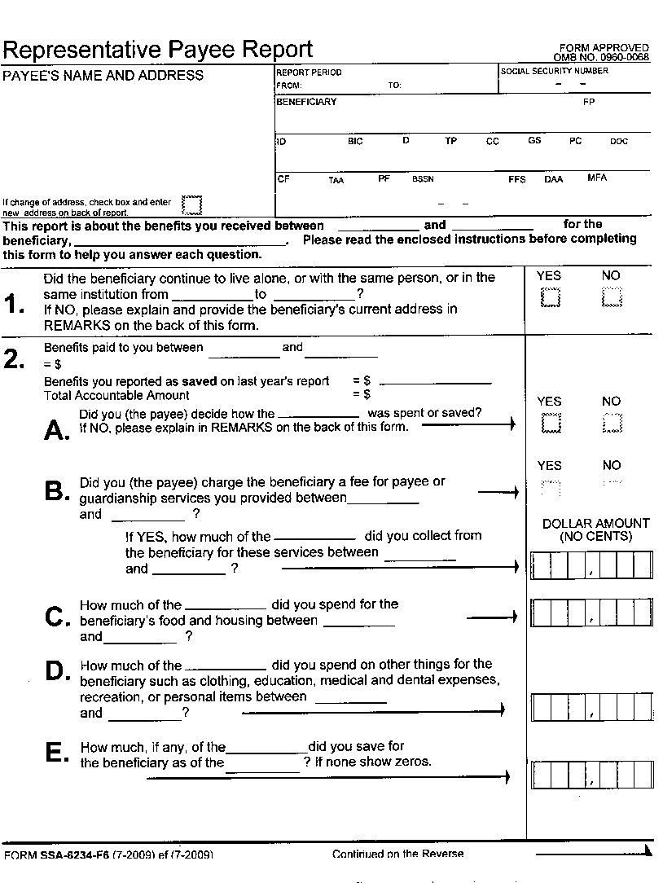
Exhibit 1 – Sample SSA-6234 Representative Payee Report
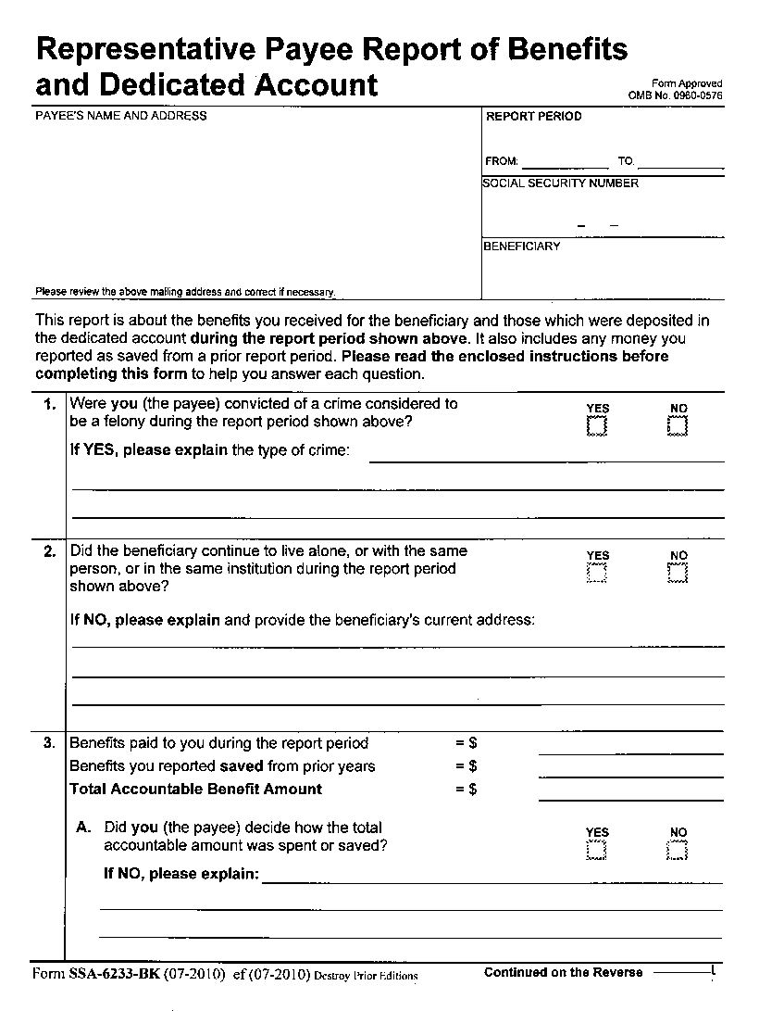
Exhibit 2 – Sample SSA-6233-BK Representative Payee Report
of Benefits and Dedicated Account

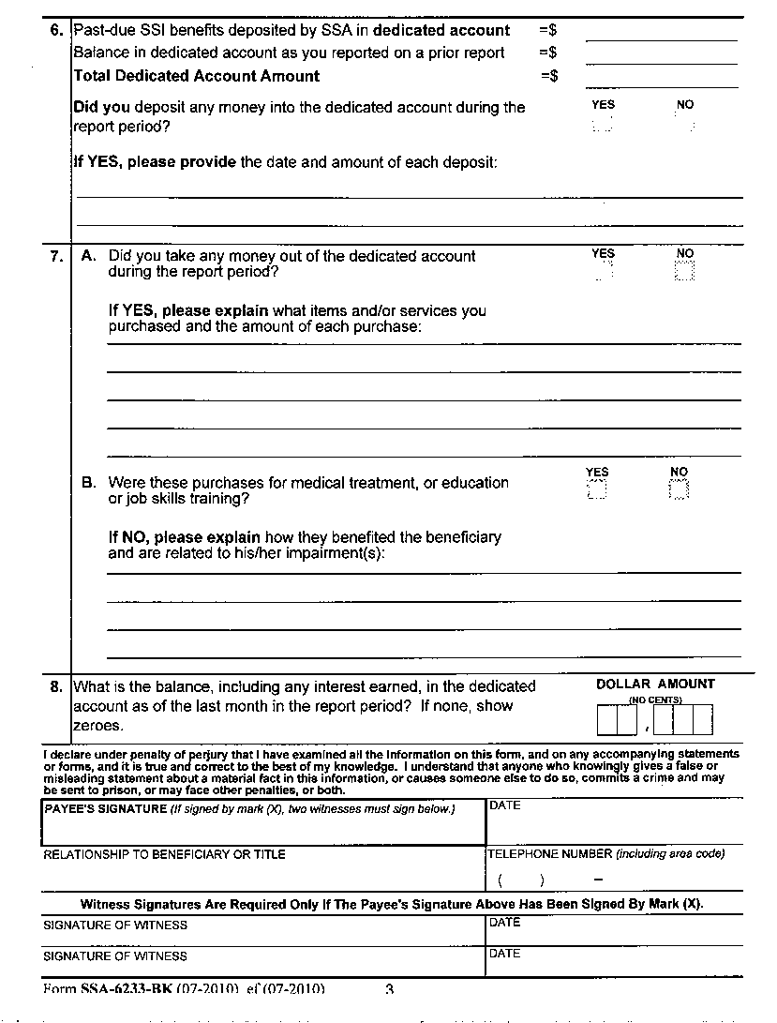Exhibit 3 – Sample Contract for Payee and Beneficiary
REPRESENTATIVE PAYMENT CONTRACT

I [name of beneficiary} have discussed my needs with [name of organization representative] and I agree to have [name of organization] serve as my representative payee for Social Security or SSI payments.
I will:
- Be clean and sober when I come to conduct business,
- Treat staff with courtesy and respect,
- Come to conduct business only on [days and hours organization has set up],
- Receive $[amount] for spending money every [length of time] as agreed, S
- Sign a receipt when I receive my spending money.
- I understand that if I fail to comply with these rules, [Organization] may refuse to continue to serve as my representative payee.
[name of organization] will:
- Treat me with courtesy and respect;
- Be available on [days and hours organization has set up] to meet with me;
- Use funds received on my behalf to meet my current needs for shelter, food, clothing and medical care;
- Report to SSA any events that may affect my eligibility for payments or payment amount;
- Account to SSA on how my money has been spent or saved;
- Save any unspent funds, if any, in a way that clearly shows the funds belong to me; and
- Return to SSA any funds saved for me (in the event of a change in payee) or that were sent for my benefit but to which I am not entitled.
Beneficiary
Signature _________________________________________________________Date_________________
Organization Signature________________________________________________________________Date___________________
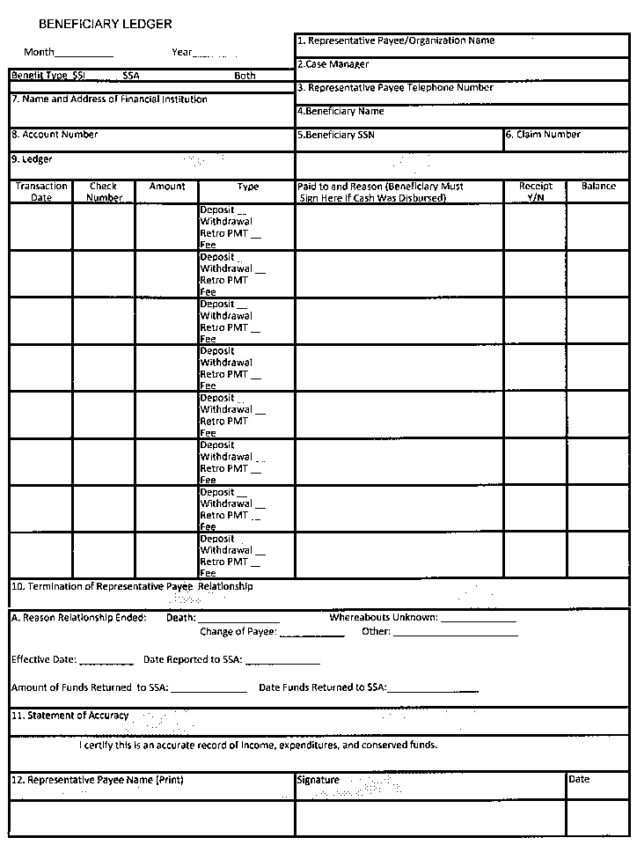Exhibit 4 – Monthly Beneficiary Accounting Ledger

